Essential Questions:
What are some of the characteristics of the graph of a square root function?
Learning Goals:
- I can graph square root functions.
- I can compare square root functions using average rates of change.
- I can solve real-life problems involving square root functions.

A _______________________________ is a function that contains a square root with the independent variable in the ________________.
*The parent function for square root functions is: _______________________.
*The domain is : __________________ and the range is: __________________.

I can graph square root functions.
Example 1: Describing the Domain of a Square Root Function
*Remember: The value of the radicand in a square root function _____________________________.
Therefore, the domain of a square root function includes x-values that are _____________________.

Describe the domain of the following square root functions.
1) $f\left(x\right)= 5\sqrt{x-6 }$ 2) $f\left(x\right)= \sqrt{3x }$

You-Try: You-Try:
1) $f\left(x\right)= \sqrt{-x+8 }$ 2) $f\left(x\right)= \sqrt{x-7 }$

Example 2: Graphing a Square Root Function
Step 1: ______________________________________________________________________
Step 2: ______________________________________________________________________
Step 3: ______________________________________________________________________
Graph the function. Describe the range.
1) g$\left(x\right)= \sqrt{x-7}$ 2) g$\left(x\right)= 8\sqrt{x}$
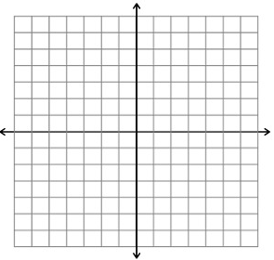
You-Try: You-Try:
1) g$\left(x\right)= \sqrt{x+5}$ 2) g$\left(x\right)= 2\sqrt{x-5}$

Transformation | f(x) notation | Examples
Horizontal Translation

Vertical Translation

Reflection

Horizontal Stretch or Shrink

Vertical Stretch or Shrink

Example 3: Comparing Graphs of Square Root Functions
Graph the function. Compare the graph to the graph of $f\left(x\right)= \sqrt{x}$.
1) f(x)$= \frac{1}{4}\sqrt{x}$ 2) $m\left(x\right)= -3\sqrt{x}$
n

You-Try: You-Try:
1) f(x)$= \frac{2}{3}\sqrt{x}$ 2) $m\left(x\right)= -4\sqrt{2x}$

Example 4: Graphing $y= a\sqrt{x-h}+ k$
Describe the transformations from the graph of $f(x)= \sqrt{x}$ to the graph of g.
1) $g\left(x\right)= -3\sqrt{x+4}- 2$

You-Try:
1) $g\left(x\right)= 5\sqrt{x-1}+ 7$

I can compare square root functions using average rates of change
I can solve real-life problems involving square root functions.
Example 5: Comparing Square Root Functions
Using the graph below, the model $v(d)= \sqrt{2gd}$ represents the velocity v (in meters per second) of a free-falling object on the moon, where g is the constant 1.6 meters per second squared and d is the distance (in meters) the object has fallen. Compare the velocities by finding and interpreting their average rates of change over the interval d = 10 and d = 20.
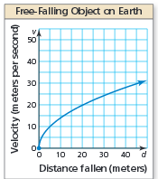
Example 6: Real-Life Application (You-Try)
The distance d (in miles) that you can see to the horizon can be modeled by $d\left(x\right)= \sqrt{\frac{3x}{2}}$, where x is the height of your eye level in feet) above ground.
a) Use a graphing calculator to graph the function. At what eye-level height does the distance you can see to the horizon exceed 6 miles?

b) What happens to the average rate of change of the distance as your eye-level height increases?

Closure: What I learned today was…

