Success Criteria Self Evaluation
Rate your level of understanding with the scale below before beginning the review activity. After completing the review activity, rate your level of understanding again. This will help identify any s that need to be re-looked at before the assessment, which is next class.
1 = Need Help! 2 = Kind Of! 3 = Almost! 4 = Got It!
Section | Success Criteria | Rating Before Activity | Rating After Activity
10.1 | I can graph square root functions. | 1 2 3 4 | 1 2 3 4
 | I can compare square root functions using average rates of change. | 1 2 3 4 | 1 2 3 4
 | I can solve real-life problems involving square root functions. | 1 2 3 4 | 1 2 3 4
10.2 | I can graph cube root functions. | 1 2 3 4 | 1 2 3 4
 | I can compare cube root functions using average rates of change. | 1 2 3 4 | 1 2 3 4
 | I can solve real-life problems involving cube root functions. | 1 2 3 4 | 1 2 3 4
10.3 | I can solve radical equations. | 1 2 3 4 | 1 2 3 4
 | I can identify extraneous solutions.
10.4 | I can explore inverses of functions. | 1 2 3 4 | 1 2 3 4
 | I can find inverses of functions algebraically. | 1 2 3 4 | 1 2 3 4
 | I can find inverses of nonlinear functions. | 1 2 3 4 | 1 2 3 4

Station 1:
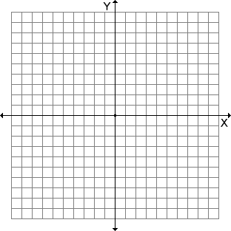
- 2.

____________________ ____________________
- 4. _________________________
_________________________
_________________________
_________________________
_________________________

____________________

Station 2:
- 2.

____________________ ____________________
3. _________________________
_________________________
_________________________
_________________________
_________________________

Station 3:
- Equation: _______________ 2. Equation: _______________

____________________ ____________________

- Equation: _______________ 4. Equation: _______________

____________________ ____________________

5. Equation: _______________ 6. Equation: _______________

____________________ ____________________

Station 4:
1.
____________________

Input
Output
- Relation: 3. Relation:
___________________________

Input
Output
Inverse: Inverse:
___________________________

Station 5:
- Function:________________ 2. Function:________________
Inverse:_________________ Inverse:_________________

3.

Inverse is a function? ___________

