Station 1 (11.1)
I can compare the mean, median, and mode of a data set
I can find the range and standard deviation of a data set
Using the following data sets, identify the mean, median, mode, standard deviation, range, and identify outliers (if any).
1. 2, 5, 16, 2, 2, 7, 3, 4, 4

2. 160, 157, 162, 158, 44, 160, 159, 161

3. Which data set has values more clustered by the mean?

4. If 2 is added to all the data in question 1, what are the new values you found in question 1?
5. If the data in question 1 is multiplied by 2, what are the new values you found in question 1?
Station 2 (11.2)
I can use box-and-whisker plots to represent data sets
I can interpret box-and-whisker plots
I can use box-and-whisker plots to compare data sets
Identify the 5 number summary, and then make a box-and-whisker plot with that information.
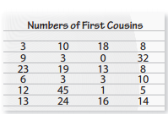

2.
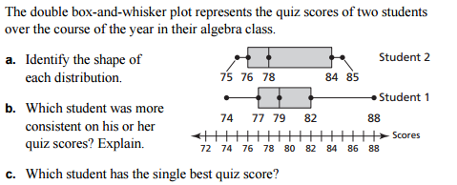
3.

Station 3 (11.3)
I can describe the shapes of data distribution
I can use the shapes of data distribution to choose appropriate measures
1) Draw a graph with the following characteristics. Then explain what you know about the data in those graphs.

1) symmetric
2) skewed left
3) skewed right

2) Explain which measure of central tendency, and measure of variation is best for each graph.

Station 4 (11.3)
I can describe the shapes of data distribution
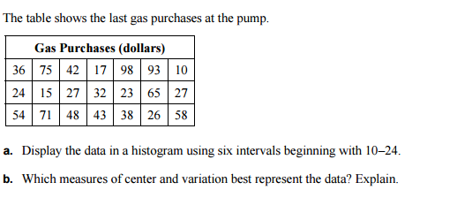
1.

Station 5 (11.4)
I can find and interpret marginal frequencies
I can make two-way tables
I can find relative and conditional relative frequencies
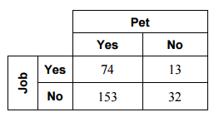
Find the relative frequencies of the following. Then answer the questions.
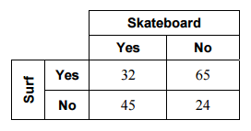
1. 2.

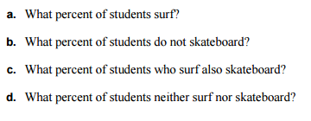
3. Complete the two-way table.
