Success Criteria Self Evaluation
Rate your level of understanding with the scale below before beginning the review activity. After completing the review activity, rate your level of understanding again. This will help identify any learning targets that need to be re-looked at before the assessment, which is next class.
1 = Need Help! 2 = Kind Of! 3 = Almost! 4 = Got It!
Section | Success Criteria | Rating Before Activity | Rating After Activity
11.1 | I can compare the mean, median, and mode of a dataset | 1 2 3 4 | 1 2 3 4
 | I can find the range and standard deviation of a data set | 1 2 3 4 | 1 2 3 4
 | I can identify the effects of transformations on data sets | 1 2 3 4 | 1 2 3 4
11.2 | I can use box-and-whisker plots to represent data sets | 1 2 3 4 | 1 2 3 4
 | I can interpret box-and-whisker plots | 1 2 3 4 | 1 2 3 4
 | I can use box-and-whisker plots to compare data sets | 1 2 3 4 | 1 2 3 4
11.3 | I can describe the shapes of data distributions | 1 2 3 4 | 1 2 3 4
 | I can use the shapes of data distributions to choose appropriate measures | 1 2 3 4 | 1 2 3 4
 | I can compare data distributions | 1 2 3 4 | 1 2 3 4
11.4 | I can find and interpret marginal frequencies | 1 2 3 4 | 1 2 3 4
 | I can make two-way tables | 1 2 3 4 | 1 2 3 4
 | I can find relative and conditional relative frequencies | 1 2 3 4 | 1 2 3 4
 | I can use two-way tables to recognize associations in data | 1 2 3 4 | 1 2 3 4

Station 1:
1. mean: 2. mean:
median: median:
mode: mode:
standard deviation: standard deviation:
range: range:
outlier: outlier:

3. _____________________________________________________________________
4. mean: 5. mean:
median: median:
mode: mode:
standard deviation: standard deviation:
range: range:
outlier: outlier:

Station 2:
1: minimum:
Q1:
median:
Q3:
maximum:

______________________________________________________________________________

2: minimum:
Q1:
median:
Q3:
maximum:

______________________________________________________________________________
3. a. Student 1:_______________________ Student 2:_________________________
b. _________________________________________________________________
c. __________________________________________________________________

Station 3:
1. symmetric: skewed left skewed right

2. Central Tendency: ____________ ____________ ____________
Variation: ____________ ____________ ____________

Station 4:
1. a. histogram: b. Center: __________
Variation: ________

Station 5:
1. 2.
relative frequencies:
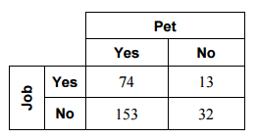
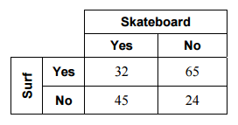

a)

b)

c)

d)

3.
