Essential Questions:
How can you use an inequality to describe a real-life statement?
How can you use addition/subtraction/division to solve an inequality?

Learning Targets:
- I can write linear inequalities
- I can sketch the graphs of linear inequalities
- I can write linear inequalities from graphs
Inequality Symbols
Symbol | < | > | ≤ | ≥
Key Phrases | -is less than  -is fewer than | -is greater than  -is more than | -is less than or equal to  -is at most  -is no more than | -is greater than or equal to  -is at least  -is no less than

Writing Inequalities:
- A number c plus 9.4 is greater than or equal to -6.

- Six is greater than a number p minus 8.

- Ten is no more than the sum of 3 times a number y and 4.

You-Try Problems
- One-third of a number h is less than 15. b) The sum of a number u and 14 is
more than 6.

Sketching the Graphs of Linear Inequalities:
*A solution of an inequality is a value that makes the inequality true, a range of true solutions.

Checking Solutions and Graphing Inequalities:
Tell whether 3 is a solution of each inequality:
- x – 7 > -5 b) -3x ≤ -12.5

Tell whether the value is a solution of the inequality:
- d – 7 < 12; d = 19 b) 9 ≥ 3n + 6 ; n = 1

Graph each inequality: *Remember, < or > have ____________________ and ≤ or ≥ have ____________________________.
- x ≥ 3 b) -4 > y c) x ≤ -2 d) x < 1

Write the inequality that represents the graph:
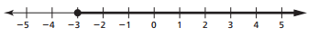
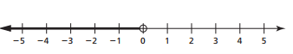
- b)

You – Try Problems
Write the inequality that represents the graph:
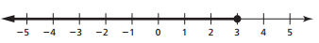
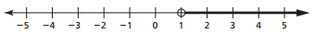
- b)

Closure: What I learned today was…..

