Essential Question:
What is a function?
Learning Targets:
- I can determine whether relations are functions
- I can find the domain and range of a function
- I can identify the independent and dependent variables of functions
Determining Whether Relations are Functions
A _______________ pairs ___________ with _____________.
NOTE: A relation that pairs each input with ___________________ output is a _______________.
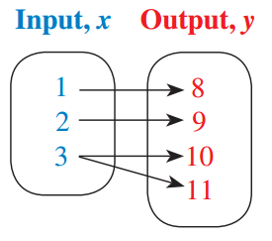
Example 1: Determine whether each relation is a function. Explain.
Input, x | 8 | 4 | 2 | 4 | 8
Output, y | −4 | −2 | 0 | 2 | 4
- b)

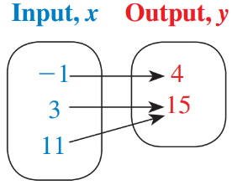
You try:
Input, x | 0 | 2 | 4 | 6 | 8
Output, y | 3 | 7 | 11 | 15 | 19
- d)

Vertical Line Test
When a relation is graphed, we can use the vertical line test to determine if the relation is a function.
A graph represents a function when __________________________ passes through more than ______ point on the graph.

Example 2: Determine whether each graph represents a function. Explain.
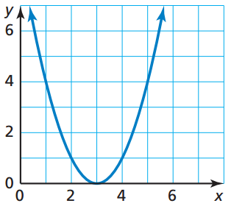
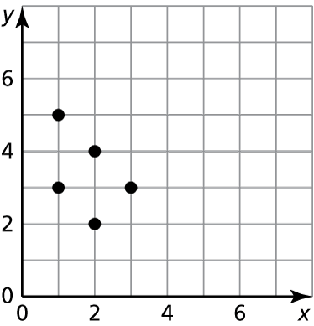
- b)

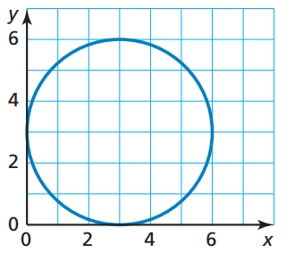
You try:
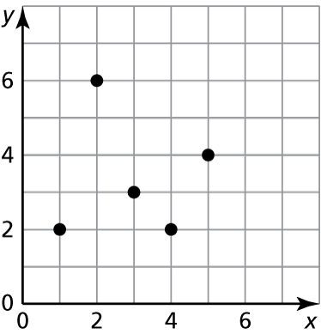
- d)

Finding the Domain and Range of a Function
The DOMAIN of a function is the set of all possible ___________________ values.
The RANGE of a function is the set of all possible ____________________ values.
Example 3: Find the domain and range of the function represented by the graph.
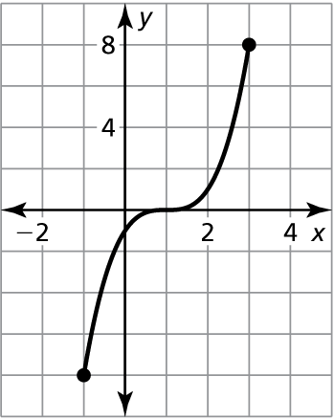
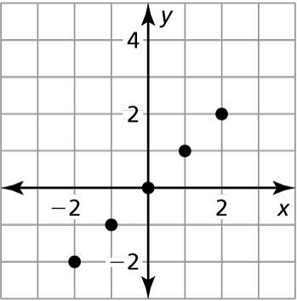
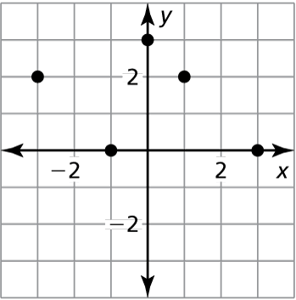
- b) c)

D: _______________ D: _______________ D: _______________
R: _______________ R: _______________ R: _______________

Identifying Independent and Dependent Variables
The variable that represents the INPUT values is the ______________________ variable.
The variable that represents the OUTPUT values is the ______________________ variable because it depends on the value of the independent variable.

The statement “y is a function of x” means that y varies or “depends” on x.
Example:

Example 4: The function y = 7x + 35 represents the monthly cost y (in dollars) of a group of x members joining the fitness club.
- Identify the independent and dependent variables.

Independent: _____________________ Dependent: ___________________
- Your group has enough money for up to six members to join the fitness club. Find the domain and range of the function.

Domain: ____________________ Range: _________________________

You try: The function a = -4b + 14 represents the number a of avocados you have left after making b batches of guacamole.
- Identify the independent and dependent variables.

Independent: _______________________ Dependent: ______________________

- The domain is 0, 1, 2, 3. What is the range? __________________

Closure: What I learned today was…

