Essential Question:
How can you determine whether a function is linear or nonlinear?
Learning Targets:
- I can identify linear functions using graphs, tables, and equations
- I can classify data as being discrete or continuous
- I can write real-life problems to fit data

Identifying Linear Functions
- A _________________________________________________, x and y, is an equation that can be written in the form ________________, where _____ and _____ are constants. The graph is a line.

- A _______________________________ is a function whose graph is a nonvertical line. It has a CONSTANT RATE OF CHANGE.

- A __________________________ does not have a ________________________________, so its graph is NOT a line.

Identifying Linear Functions Using Graphs, Tables, and Equations
Example 1: Identify whether the following represent linear or nonlinear functions. Explain.
x | 1 | 4 | 7 | 10
y | 2 | 5 | 6 | 10
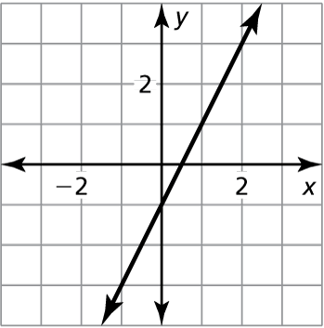
- b)

- y = 9 – x d) y = (x – 1)(x + 7)

You try:
x | 0 | 1 | 2 | 3
y | 3 | 5 | 7 | 9
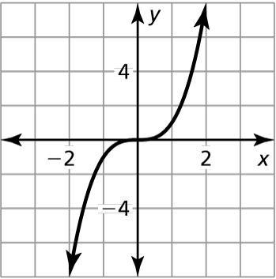
- b)

- d) y = 4x – 2

Graphing Linear Functions
A _________________ of a linear equation in two variables is an ordered pair (x, y) that makes the equation true. The graph of a linear equation is the set of all of these ordered pairs.

Discrete and Continuous Domains
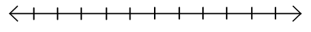
A __________________________ is a set of input values that consists of ____________________ numbers in an interval.

A __________________________ is a set of input values that consists of ____________________ in an interval.

Example 2: Find the domain of the functions represented by the graph. Determine whether the domain is discrete or continuous. Explain.
Input  Months, x | 1 | 2 | 3
Output  Height of basil plant (inches), y | 3 | 7 | 11
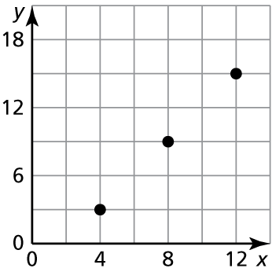
- b)

D: __________________ D: __________________
DISCRETE or CONTINUOUS DISCRETE or CONTINUOUS
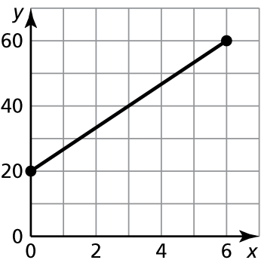
You try:
Input  Tickets, x | 10 | 20 | 30
Output  Cost (dollars), y | 60 | 120 | 180
- d)

D: __________________ D: __________________
DISCRETE or CONTINUOUS DISCRETE or CONTINUOUS
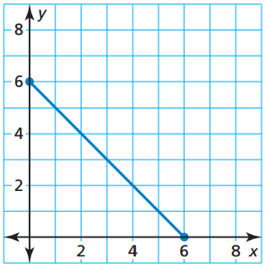
Partner Activity: With a partner, write a real-life problem to fit the data shown in each graph. Is the domain of each function discrete or continuous? Explain.
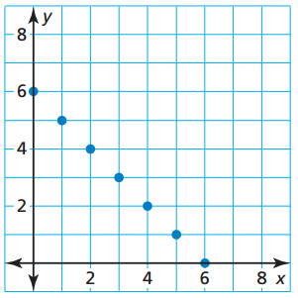
- b)

Closure: What I learned today was…

