Essential Question: Given the graph of a linear function, how can you write an equation of the line?

Learning Goals:
- I can write equations in slope-intercept form
- I can use linear equations to solve real-life problems

I can write equations in slope-intercept form
Recall: Slope-intercept form is: _____________________
Where _____ is slope and _____ is the y-intercept

Writing Equations in Slope-Intercept Form: Write an equation of each line with the given slope and y-intercept.
a) slope = 3 y-intercept = -1 b) slope = $\frac{1}{2}$ y-intercept = 0

You try:
a) slope = $\frac{3}{4}$ y-intercept = 8 b) slope = 0 y-intercept = $-\frac{2}{3}$

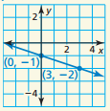
Using Graphs to Write Equations: Write an equation of each line in slope-intercept form.
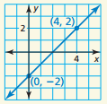
a) b)

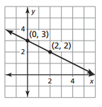
You try:
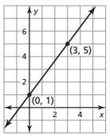
a) b)

Using Points to Write Equations: Write an equation of each line that passes through the given points.
a) $\left(0, -6\right), (3, 9)$ b) $\left(4, -1\right), (0, 2)$

You try:
a) $\left(2, 3\right), (0, 9)$ b) $\left(5, -2\right), (0, -2)$

Writing a Linear Functions: Write a linear function $f$ with the following:
a) $f\left(0\right)=-4 and f\left(3\right)=8$

You try:
$f\left(3\right)=-2, f\left(0\right)=1$

At this point you should be able to write equations in slope-intercept form – can you??
I can use linear equations to solve real-life problems
In 2000, the average cost for college tuition in the United States was about $14,000. In 2010, the cost was about $18,000. Write a linear model that represents the cost of tuition as a function of the number of years since 2000. Use the model to predict the cost in 2020.

You try:
In 2003, a gallon of gas cost $1.75. In 2013, a gallon of gas cost $3.50. Write a linear model that represents the cost (in dollars) of a gallon of gas as a function of the number of years since 2003. Use the model to predict the cost of a gallon of gas in 2012.

Closure: What I learned today was…..

