Essential Question: How can you write an equation of a line when you are given the slope and a point on the line?
Learning Goals:
- I can write an equation of a line given its slope and a point on the line.
- I can write an equation of a line given two points on the line.
- I can use linear equations to solve real-life problems

I can write an equation of a line given its slope and a point on the line
What is point-slope form?

Where does it come from? Suppose a line passes through (3, 4) and has slope $\frac{1}{2}$

Write an equation in point-slope form of the line with the following:
a) passes through (1, 6) and has slope $-\frac{1}{2}$ b) passes through (4, -3) and has slope $m=-5$

You try:
a) passes through (2, 7) and has slope $m=-3$ b) passes through (3, 1) and has slope 4

I can write an equation of a line given two points on the line
When you are given two points on a line, you can write an equation of the line using the following steps:
Step 1:______________________
Step 2: ___________________________________________________________________
___________________________________________________________________
Write an equation in slope-intercept form using the information given:
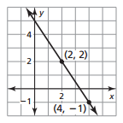
a) b) $f\left(8\right)=-1 and f\left(6\right)=0$

c) $\left(6, 3\right)$ and $(3, 10)$ d) 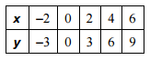

You try:
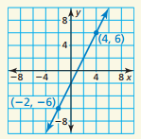
a) b) $f\left(1\right)=3 and f\left(3\right)=4$

c) $(5, -4)$ and $(15, 2)$ d) 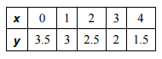

I can use linear equations to solve real-life problems
To ride in a Best-in-Town taxi, you pay a start fee and a mileage fee. The table shows the total cost of a taxi ride for different distances. Can the situation be modeled by a linear equation? Explain. If possible, write a linear model that represents the cost as a function of the number of miles.
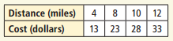

You try:
You pay an installation fee and a monthly fee for Internet Service. The table shows the total cost for different numbers of months. Can the situation be modeled by a linear equation? Explain. If possible, write a linear model that represents the total cost as a function of the number of months.
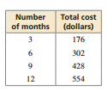

Closure: What I learned today was…..

