Essential Question: How can you recognize lines that are parallel or perpendicular?

Learning Goals:
- I can identify and write equations of parallel lines
- I can identify and write equations of perpendicular lines
- I can use parallel and perpendicular lines in real-life problems

I can identify and write equations of parallel lines
Parallel Lines:

Two distinct nonvertical lines are parallel if and only if they have the __________________.
(All vertical lines are parallel!)
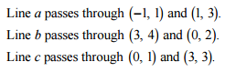
Determine which of the lines are parallel:
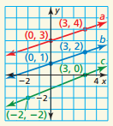
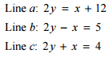
a) b) c)

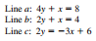
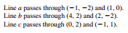
You try:
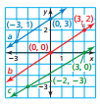
a) b) c)

Write an equation of the line that passes through the given point and is parallel to the line given.
(3, 1) $y=3x+1$

You try: (-1, 3) $y=2x+2$

Can you identify and write equations of parallel lines???

I can identify and write equations of perpendicular lines
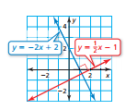
Perpendicular Lines:

Nonvertical lines are perpendicular if and only if their slopes are negative reciprocals.

Determine which of the lines, if any, are perpendicular.
a) Line a: $y=\frac{2}{3}x+3$ Line b: $3x+2y=8$ Line c: $3y-2x=-9$

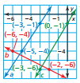
b)

You try:
a) Line a passes through (-2, 1) and (0, 3). Line b passes through (4, 1) and (6, 4). Line c passes through (1, 3) and (4, 1)

b) Line a: $4x-3y=2$ Line b: $y=\frac{4}{3}x+2$ Line c: $4y+3x=4$

Write an equation of a line that passes through the given point and is perpendicular to the given line.
(4, -3) $y=4x-1$

You try: (7, 10) $y=\frac{1}{2}x-9$

Can you identify and write equations for perpendicular lines now???
I can use parallel and perpendicular lines in real-life problems
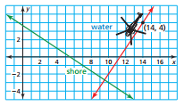
A helicopter is at (8, 5). The shortest flight path to the shoreline is one that is perpendicular to the shoreline. Write an equation that represents the path.

You try:
Another helicopter is at (4, -2). It is flying parallel to the helicopter shown. What is the equation to represent the path?

Closure: What I learned today was…..

