Essential Questions:
- How can you use an arithmetic sequence to describe a pattern?
Learning Goals:
- I can write the terms of arithmetic sequences
- I can graph arithmetic sequences
- I can write arithmetic sequences as functions
Sequence: an ordered list of ___________, called _________; notation- ______.
Each term has a specific position n in the sequence.
4, 8, 12, …, a_{n}
Arithmetic sequence: the _____________ between each pair of _______________ terms is the same. This is known as the _____________ _______________. Each term can be found by adding the _____________ _______________ to the previous term.

I can write the terms of arithmetic sequences
Example 1: Write the next three terms of the arithmetic sequence.
- -2, 6, 14, 22, ____, ____, ____ b. 3, 0, -3, -6, ____, ____, ____

- You try: 40, 44, 48, 52, ____, ____, ____ d. You try: 0.5, 1, 1.5, 2, ____, ____, ____

I can graph arithmetic sequences
Example 2: Graph the arithmetic sequences from parts b and d above. What do you notice?
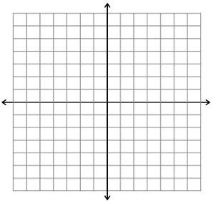
- d.

Example 3: Does the graph represent an arithmetic sequence? Explain.
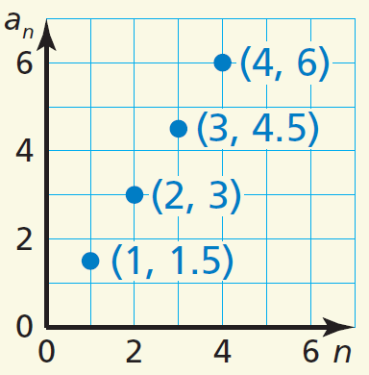
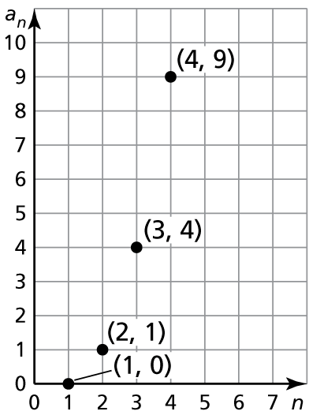
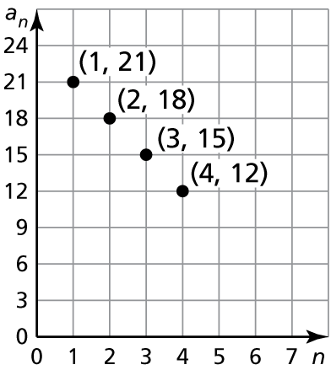
a. b. c. You try:

I Can Write Arithmetic Sequences as Functions
Since consecutive terms in an arithmetic sequence have a common different, the sequence has a _________ _______ of __________.
Position, n Term, a_{n} Written using a₁ and d Numbers

From this, we have the equation for an arithmetic sequence: ______________________
Example 4: Write an equation for the nth term of the arithmetic sequence 7, 3, -1, 5, … Then find a₃₀.

You try: Write an equation for the nth term of the arithmetic sequence 1, 0, -1, -2, … Then find a₅₁.

The equation for an arithmetic sequence can also be written using function notation by replacing ____ with ________.
Example 5: Juan saves $12 the first week of the year. He will increase the amount he saves each week by $4.
- Write a function that represents the arithmetic sequence. _____________________
- Graph the function.


- Juan’s goal is to save $68 in one week. In which week will he save that amount? _____________

Closure: What I learned today was…

