Essential Questions:
- How can you describe a function that is represented by more than one equation?
Learning Goals:
- I can evaluate piecewise functions
- I can graph and write piecewise functions
- I can graph and write step functions
- I can write absolute value functions
Piecewise Function: a function defined by _________________________________. Each ________ of the function applies to a different part of its _____________.
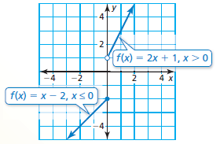
The piecewise function, $f\left(x\right)= \left\{\begin{aligned}x-2, if x≤0 \\ 2x+1, if x>0\end{aligned}\right.$, has the following graph:

I can evaluate piecewise functions
Example 1: Evaluate the function
$$f\left(x\right)= \left\{\begin{aligned}x-2, if x≤0 \\ 2x+1, if x>0\end{aligned}\right.$$

- when x = -1 ___________
- when x = 1 ___________

You try: Evaluate the above function:
- when x = 0 ___________
- when x = 5 ___________

Example 2: Evaluate the function. $f\left(x\right)=\left\{\begin{aligned}3, if x< -2 \\ x+2, if-2≤x≤5 \\ 4x, if x>5\end{aligned}\right.$
- f(-7) = ________ b. f(-2) = ________ c. f(1) = ________
You try:
- f(4) = ________ e. f(5) = ________ f. f(12) = ________

I can graph and write Piecewise Functions
Step 1: Graph each “piece” separately for the given domain (x values).
Step 2: Pay close attention to the inequality sign to see if the piece ends with an ______ or _________ circle, or an arrow.
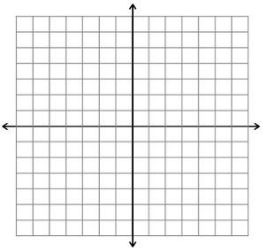
Example 3: Graph $y= \left\{\begin{aligned}-x+2, if x≤0 \\ 2x, if x>0\end{aligned}\right.$. Describe the domain and range.

You try: Graph $f\left(x\right)=\left\{\begin{aligned}x+6, if x< -2 \\ -2x, if x≥-2\end{aligned}\right.$. Describe the domain and range.

Now, we can look at the reverse of the previous example- write the equation of the piecewise function, given its graph.
Example 4: Write a piecewise function for the graph.
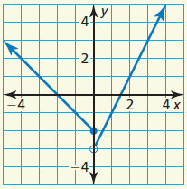
a.

f(x) =

b. You try
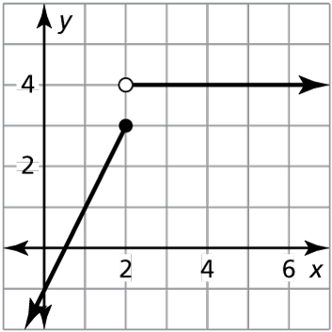
f(x) =

I can graph and write step functions
Step function: a piecewise function defined by a ____________ _________ over each part of its domain. The graph of a step function consists of a series of _______ ______________.
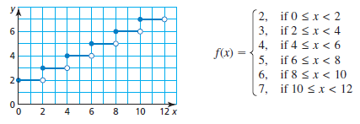
Example 5: Graph the following step functions.
- $y= \left\{\begin{aligned}5, if-2≤x<0 \\ 3, if 0≤x<2 \\ 1, if 2≤x<4\end{aligned}\right.$ b. You try:

Example 6: You rent a bicycle for 4 days. The bike store charges $20 for the first day and $15 for each additional day. Write and graph a step function that represents the relationship between the number x of days and the total cost y (in dollars) of renting the bicycle.

I can write absolute value functions
We can write absolute value functions, ____________, as a piecewise function:
$$f\left(x\right)=\left\{\begin{aligned} , if x<0 \\ , if x ≥0\end{aligned}\right.$$
With the ________ form of an absolute value function, g(x) = a│x-h│+ k, we can also write a piecewise function:
$$g\left(x\right)=\left\{\begin{aligned} , if x-h<0 \\ , if x-h ≥0\end{aligned}\right.$$
Example 7: Write the absolute value function as a piecewise function.
- f(x) = │x-3│ b. g(x) = -2│x + 4│

- You try: h(x) = - │x + 1│

Closure: What I learned today was…

