1) How can you tell whether an ordered pair is a solution of a linear inequality?

Tell whether the ordered pair is a solution of the inequality.
2) x + y < 7; (2,3) 3) –x – 6y > 12; (-8, 2)

Tell whether the ordered pair is a solution to the system of inequalities.
4) (1, -1); y < 4 and y > x + 3 5) (4, -3); y ≤ -x + 1 and y > x – 5

Tell whether the ordered pair is a solution of the inequality whose graph is shown.
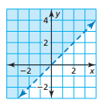
6) (0, -1) 7) (-1, 3) 8) (1, 4)

9) (0, 0) 10) (3, 3) 11) (2, 1)

Graph the inequality (or system of inequalities) in a coordinate plane.
12) y ≤ 5 13) y > -2x – 4

14) y < x – 1; y ≥ x + 1 15) 2x + y ≤ 5; y + 2 ≥ -2x
Describe AND correct the error in graphing the inequality (or system of inequalities).
16) 17) 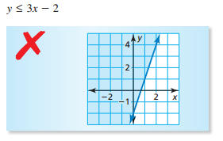 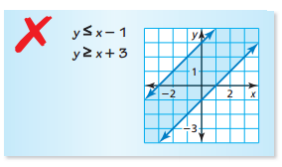
Write an inequality that represents the graph.
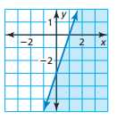
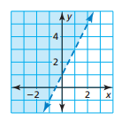
18) 19)

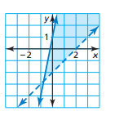
Write a system of linear inequalities represented by the graph.
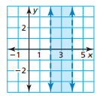
20) 21)

20) A carpenter has at most $250 to spend on lumber. The inequality 8x + 12y ≤ 250 represents the numbers x of 2-by-8 boards and the numbers y of 4-by-4 boards the carpenter can buy. Can the carpenter buy twelve 2-by-8 boards and fourteen 4-by-4 boards? Explain.
