Essential Question: How can you solve a system of linear equations?

Learning Goals:
- I can check solutions of systems of linear equations
- I can solve systems of linear equations by graphing
- I can use systems of linear equations to solve real-life problems

What is a system of linear equations?

i.e.
What is a solution to a system of linear equations?

I can check solutions of systems of linear equations
Tell whether the ordered pair is a solution of the system of linear equations.
Example: a) (5, 1) b) (-1, -5)
$x+y=6$ $y=-x+2$
$2x-y=9$ $y+2=3x$

You try: a) (2, 6) b) (-1, 3)
$x+y=8$ $y=-7x-4$
$3x-y=0$ $y=8x+5$

I can solve systems of linear equations by graphing
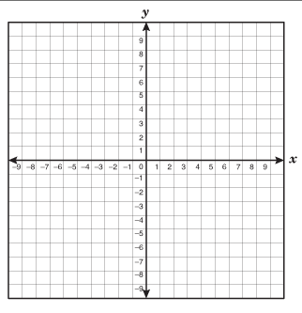
Solve the system of linear equations by graphing. Check your solution
Example: Let’s check on our calculators:
$y=\frac{1}{3}x+2$
$y=\frac{2}{3}x+5$

You try:
$y=-2x+8$
$2x-y=-4$

I can use systems of linear equations to solve real-life problems
Example: You have a total of 18 math and science exercises for homework. You have six more math exercises than science exercises. How many exercises do you have in each subject?
Define your variables!
x =
y =

You try: For the first tour on Monday, a museum sells 4 child tickets and 8 adult tickets for $64. For the second tour, the museum sells 6 adult tickets for $36. Find the price of one child ticket and the price of one adult ticket.
Define your variables
x =
y =

Closure: What I learned today was…..

