Essential Question: Can a system of linear equations have no solution or infinitely many solutions?

Learning Goals:
- I can determine the numbers of solutions of linear systems.
- I can use linear systems to solve real-life problems

Solutions of Systems of Linear Equations
A system of linear equations can have:
One Solution No Solution Infinitely Many Solutions

I can determine the numbers of solutions of linear systems.
Solve the system of linear equations (use any method of solving you want!)
Example: a)$y=3x+2$ b) $x-3y=6$
$3x=y+1$ $3x-9y=18$

What does it mean?

You try: a) $x+y=3$ b) $y=-x+3$
$2x+2y=6$ $2x+2y=4$

I can use systems of linear equations to solve real-life problems
Example: The perimeter of the trapezoidal piece of land is 96 km. The perimeter of the rectangular piece of land is 144 km. Write and solve a system of linear equations to find the values of x and y.
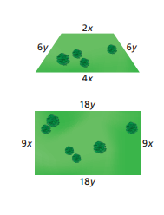

You try: Now the perimeter of the trapezoidal piece above is 72 km. The perimeter of the rectangular piece is now 216 km. Write and solve a system of linear equations to find the values of x and y.

Closure: What I learned today was…..

