Essential Question:
- What are some of the characteristics of the graph of an exponential function?
Learning Targets:
- I can identify and evaluate exponential functions
- I can graph exponential functions
- I can solve real – life problems involving exponential functions

Identifying and Evaluating Exponential Functions
An __________________________ is a nonlinear function of the form ________ where _____________________________. As the independent variable x changes by a __________________, the dependent variable y is multiplied by a ___________________
which means consecutive y-values form a ______________________ (multiplied by the same value).

y = ab^{x}

Example 1: Identifying functions
Does each table represent a linear or an exponential function? Explain.
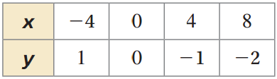
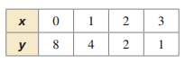
- 2)

You try:
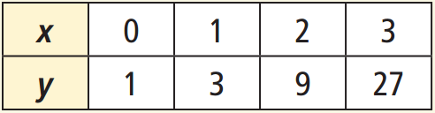
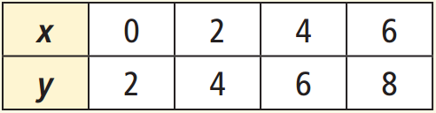
- 2)

Example 2: Evaluating Exponential Functions
Evaluate each function for the given value of x.
- y = -2(5)^{x} ; x = 3 2) y = 3(0.5)^{x} ; x = -2

You try: Evaluate the function of y = 2(9)^{x} when x = -2, 0, and $\frac{1}{2}$

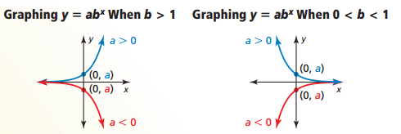
Graphing Exponential Functions

Example 3: Graphing y = ab^{x} when b > 1
Graph f(x) = 4(2)^{x} . Compare the graph to the graph of the parent function. Describe the domain and range of f.
x | y
-2
-1
0
1
2

D: __________________

R: __________________

Example 4: Graphing y = ab^{x} when 0 < b < 1
Graph f(x) = -${\left(\frac{1}{2}\right)}^{x}$. Compare the graph to the graph of the parent function. Describe the domain and range of f.
x | y
-2
-1
0
1
2
D: __________________

R: __________________

You try:
Graph the function . Compare the graph to the graph of the parent function. Describe the domain and range of f.
- f(x) = =2(4)^{x} 2) f(x) = 2${\left(\frac{1}{4}\right)}^{x}$
x | y
-2
-1
0
1
2
x | y
-2
-1
0
1
2

D: _____________ R: _____________ D: _____________ R: _____________

Example 5: Graphing y = ab^{x – h} + k
Graph y = 4(2)^{x – 3} + 2 and y = 4(2)^{x}. Describe the domain and range. What does the “h” and “k” values do to the graph?
x | y
-2
-1
0
1
2
D: ________________
R: ________________

You try: Graph y = -2(3)^{x +2} -1. Describe the domain and range.
x | y
-4
-3
-2
-1
0
D: ________________
R: ________________

Example 6: Comparing Exponential Functions
An exponential function g models a relationship in which the dependent variable y is multiplied by 1.5 for every 1 unit the independent variable x increases. Graph g when g(0) = 4. Compare g and the function f from Example 3 over the interval x = 0 to x = 2.
x | y
-1
0
1
2
3
Comparison: ___________________________
____________________________________
____________________________________

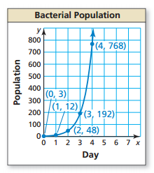
Example 7: Modeling with Mathematics
The graph represents a bacterial population y after x days.
- Write an exponential function that represents the population.

- Find the population after 12 hours and after 5 days.

You try:
A bacterial population y after x days can be represented by an exponential function whose graph passes through (0, 100) and (1, 200).
- Write a function that represents the population.

- Find the population after 6 days.

- Does this bacterial population grow faster than the bacterial population in the previous example? Explain.

Closure: What I learned today was…

