Essential Question:
- What are some of the characteristics of exponential growth and exponential decay function?
Learning Targets:
- I can use and identify exponential growth and decay functions.
- I can interpret and rewrite exponential growth and decay functions.
- I can solve real-life problems involving exponential growth and decay.

Exponential Growth Function: A function of the form _______________________ where _______, and ________.

y = a(1 + r)^{t}

Example 1: Using an Exponential Growth Function
The inaugural attendance of an annual music festival is 80,000. The attendance y increases by 6% each year.
- Write an exponential growth function that represents the attendance after t years.

- How many people will attend the festival in the 5th year? Round your answer the nearest thousand.

You try:
A website has 500,000 members in 2010. The number y of members increases by 15% each year.
- Write an exponential growth function that represents the website membership t years after 2010.

- How many members will there be in 2017? Round your answer to the nearest ten thousand.

Exponential Decay Function: A function of the form _______________________ where _______, and _____________.

y = a(1 - r)^{t}

**For exponential growth, the value inside the parentheses is ________________________________
because r is added to 1. For exponential decay, the value inside the parentheses is ________________
because r is subtracted from 1.

Example 2: Identifying Exponential Growth and Decay
Determine whether each table represents an exponential growth function, an exponential decay function, or neither.
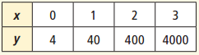
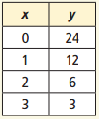
- 2)

You try:
Determine whether the table represents an exponential growth function, an exponential decay function, or neither.
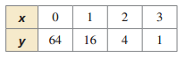
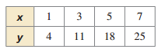
- 2)

Example 3: Interpreting Exponential Functions
Determine whether each function represents exponential growth or exponential decay. Identify the rate of change.
- y = 5(1.07)^{t} 2) f(t) = 0.2(0.98)^{t}

You try:
- y = 2(0.92)^{t} 2) f(t) = (1.2)^{t}

Example 4: Rewriting Exponential Functions
Rewrite each function to determine whether it represents exponential growth or exponential decay.
- y = 100(0.96)^{t/4} 2) f(t) = (1.1)^{t-3}

You try:
- f(t) = 3(1.02)^{10t} 4) y = (0.95)^{t+2}

Closure: What I learned today was…

