Determine whether the equation represents an exponential function. EXPLAIN.
1. y = 9x 2. y = 2(3)^{x} 3. y = (-2)^{x}

Determine whether the table represents a linear or an exponential function. EXPLAIN.
x | y
1 | 3
2 | 9
3 | 27
4 | 81
x | y
1 | 4
2 | 6
3 | 8
4 | 10
4. 5.

Evaluate the function for the given value of x.
6. y = (1.2)^{x} ; x = 2 7. f(x) = ½(8)^{x} ; x = -2

Graph the function. Compare the graph to the graph of the parent function. Describe the domain and range of f.

8. f(x) = -2(0.5)^{x} 9. f(x) = ½(6)^{x}
x | y
x | y

D: __________ R: ___________ D: __________ R: ___________
Graph the function. Describe the domain and range. What does the “h” or “k” value do to the graph?
10. f(x) = 2^{x} + 3 11. f(x) = 3^{x-2}
x | y
x | y

D: ___________ R: _______________ D: ___________ R: _______________
h/k value: h/k value:
_______________________________ _______________________________

Compare the graphs. Find the value of h, k, or a.
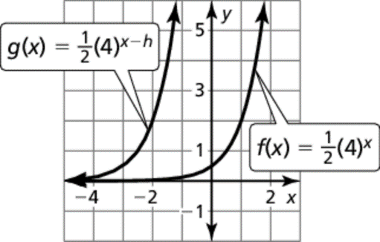
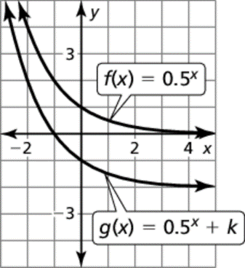
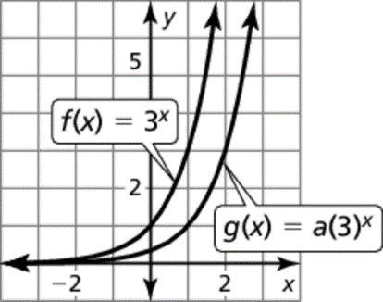
12. 13. 14.

