Learning Target Self Evaluation
Rate your level of understanding with the scale below before beginning the review activity. After completing the review activity, rate your level of understanding again. This will help identify any learning targets that need to be re-looked at before the assessment, which is next class.
1 = Need Help! 2 = Kind Of! 3 = Almost! 4 = Got It!
Section | Learning Target | Rating Before Activity | Rating After Activity
6.1 | I can rewrite expressions involving radicals…using the properties of exponents | 1 2 3 4 | 1 2 3 4
6.2 | I can find nth roots | 1 2 3 4 | 1 2 3 4
 | I can evaluate expressions with rational exponents | 1 2 3 4 | 1 2 3 4
 | I can solve real-life problems involving rational exponents | 1 2 3 4 | 1 2 3 4
6.3 | I can identify and evaluate exponential functions | 1 2 3 4 | 1 2 3 4
 | I can graph exponential functions | 1 2 3 4 | 1 2 3 4
 | I can solve real-life problems involving exponential functions | 1 2 3 4 | 1 2 3 4
6.4 | I can use and identify exponential growth and decay functions | 1 2 3 4 | 1 2 3 4
 | I can interpret and rewrite exponential growth and decay functions | 1 2 3 4 | 1 2 3 4
 | I can solve real-life problems involving exponential growth and decay | 1 2 3 4 | 1 2 3 4

Station 1
I can rewrite expressions involving radicals…using the properties of exponents.

- ______________________ 2. ______________________

- ______________________ 4. ______________________

- ______________________ 6. ______________________

- ______________________ 8. ______________________

- ______________________

Station 2
I can evaluate expressions with rational exponents.
- ________ 2. ________ 3. ________

- ________ 5. ________ 6. ________

I can find nth roots.

- ________ 8. ________ 9. ________

Station 3
I can solve real-life problems involving rational exponents.
- ________________

I can solve real-life problems involving exponential functions.

- a) ____________________

b) ____________________
Station 4
I can identify and evaluate exponential functions.
- _______________________________________________

- _______________________________________________

- _________________ 4. _________________

I can graph exponential functions.
x | y
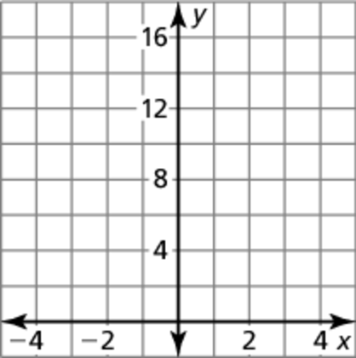
- D: _________________
R: _________________

x | y
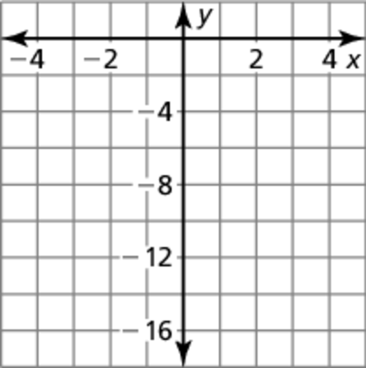
- D: _________________
R: _________________

Station 5
I can use and identify exponential growth and decay functions.

- ________________________________

- ________________________________

- ________________________________

I can interpret and rewrite exponential growth and decay functions.

- ________________________________; r = ________

- ________________________________; r = ________

Station 6
I can solve real-life problems involving exponential growth and decay.

- a. _______________________________

b. _______________________________

- a. _______________________________

b. _______________________________

