Learning Target:
- How can you multiply two polynomials
Success Criteria:
- I can multiply binomials.
- I can use the FOIL method.
- I can multiply binomials and trinomials.
I can multiply binomials.
$$(x+4)(x+1)$$
Multiplying binomials using the DISTRIBUTIVE method
Multiplying binomials using a TABLE
Multiplying binomials using the FOIL method

**Learning Target:
FOIL method**

$$(r-5)(2r^{2}-1)$$
Multiplying binomials using the DISTRIBUTIVE method
Multiplying binomials using a TABLE
Multiplying binomials using the FOIL method
**Learning Target:
FOIL method**
You try: (continued on next page!)
$$(m-3)(m+7)$$
Multiplying binomials using the DISTRIBUTIVE method
Multiplying binomials using a TABLE
Multiplying binomials using the FOIL method
**Learning Target:
FOIL method**
$(2u+\frac{1}{2})(u-\frac{3}{2})$ **challenge**
Multiplying binomials using the DISTRIBUTIVE method
Multiplying binomials using a TABLE
Multiplying binomials using the FOIL method
**Learning Target:
FOIL method**

I can multiply a binomial and a trinomial.
To multiply a binomial and trinomial we must use either ______________ or a _____________.
Example: $(x+1)(x^{2}+5x+8)$
Multiplying binomials using the DISTRIBUTIVE method
Multiplying binomials using a TABLE

You try: $(r-3)(r^{2}-2r+4)$
Multiplying binomials using the DISTRIBUTIVE method
Multiplying binomials using a TABLE

Mathematical Connections
Example: Write a polynomial that represents the area of the shaded region
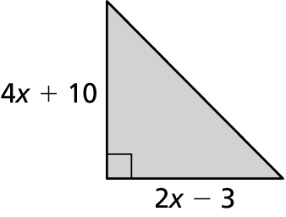

You try:
