Learning Target:
- What are the patterns in the special products $\left(a+b\right)\left(a-b\right), {(a+b)}^{2},$and ${(a-b)}^{2}$
Success Criteria:
- I can use the square of a binomial pattern.
- I can use the sum and difference pattern.
- I can use special product patterns to solve real-life problems.

I can use the square of a binomial pattern.
How can we rewrite the following ‘square of a binomial’? Then just multiply using the method of your choice!
${\left(x+7\right)}^{2}$ = ________________________ ${\left(7x-3\right)}^{2}$ = ________________________

${(3m+n)}^{2}$ = _______________________ ${(-7t+4)}^{2}$ = ________________________

I can use the sum and difference pattern.
Work with a partner to multiply the following polynomials.
1) $(x+10)(x-10)$ 2) $(2x-1)(2x+1)$ 3) $(x+3y)(x-3y)$

What do you notice?

The multiplication of these binomials follows the _____________________________.

Try these using the Sum and Difference pattern instead of multiplying:
1) $(t-7)(t+7)$ 2) $(8+3a)(8-3a)$

I can use special products to solve real- life problems.
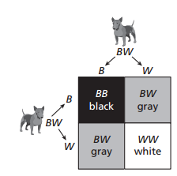
Example: Each of two dogs has one black gene (B) and one white gene (W). The Punnett square shows the possible gene combinations of an offspring and the resulting colors.
a) What percent of the possible gene combinations result in black?

b) Show how you could use polynomial to model the possible gene
combinations of the offspring.

You try: A contractor extends a house on two sides.
a) The area of the house after the renovation is represented by ${(x+50)}^{2}$. Find this product.
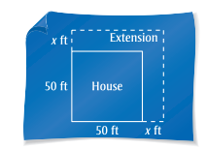

b) Use the polynomial in part (a) to find the area when $x=15$. What is the area of the extension?

