Essential Questions:
- How can you recognize and factor special products?
Learning Goals:
- I can factor the difference of two squares.
- I can factor perfect square trinomials.
- I can use factoring to solve real-life problems.

I can factor the difference of two squares.
Difference of Two Squares Pattern:

Example: Factor the polynomials.
- x² – 64 2) 25b² – 36

Evaluating a Numerical Expression
Use a special product pattern to evaluate the following expressions.
- 54² - 48² 2) 68² - 62²

You-Try: Factor the polynomial.
- 100-m² 2) 16b² – 49

You-Try: Use a special product pattern to evaluate the expression.
- 55² - 50² 2) 28² - 24²

I can factor perfect square trinomials.
Perfect Square Trinomial Pattern

Example: Factor each polynomial.
- n² + 8n + 16 2) 4x² – 12x + 9

You-Try: Factor each polynomial.
- m² – 2m + 1 2) 9z² + 36z + 36

Solving a Polynomial Equation
Example: Solve the polynomial equation.
- x² + 3x + $\frac{9}{4}$ = 0 2) n² – 81 = 0

You-Try: Solve the polynomial equation.
- a² + 6a + 9 = 0

I can use factoring to solve real-life problems.
A bird picks up a golf ball and drops it while flying. The function represents the height y (in feet) of the golf ball t seconds after it is dropped. The ball hits the top of a 32-foot-tall pine tree. After how many seconds does the ball hit the tree?

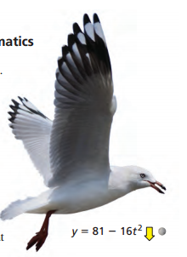

You-Try: What if the golf ball does not hit the pine tree. After how many seconds does the ball hit the ground?

