Essential Questions:
- How can you factor a polynomial completely?
Learning Goals:
- I can factor polynomials by grouping.
- I can factor polynomials completely.
- I can use factoring to solve real-life problems.

I can factor polynomials by grouping.
Used for polynomials with _______________________. Factor the GCF out of each pair of terms. Look for and factor out the _____________________________________________.

Example: Factor each polynomial by grouping.
- x³ + 3x² + 2x + 6 2) x² + y + x + xy

You-Try: Factor each polynomial by grouping.
- a³ + 3a² + a + 3 2) y² + 2x + yx + 2y

I can factor polynomials completely.
4 specific guidelines for Factoring polynomials completely:
1.

2.

3.

4.

Example: Factor completely.
- 3x³ + 6x ² – 18x 2) 7x⁴ – 28x²

You-Try: Factor completely.
- 2x³ + 6x² – 2x 2) 5x⁴ – 45x²

Solving an Equation by Factoring Completely
Example: Solve Completely.
- 2x³ + 8x = 10x 2) 3x³ + 6x² = 24x

You-Try: Solve Completely.
- w³ – 8w² + 16w = 0 2) c³ – 7c² = -12c

I can use factoring to solve real-life problems.
A terrarium in the shape of a rectangular prism has a volume of 4608 cubic inches. Its length is more than 10 inches. The dimensions of the terrarium in terms of its width are shown. Find the length, width, and height or the terrarium.
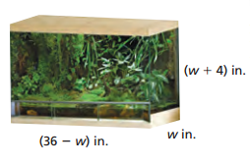

You-Try:
A box in the shape of a rectangular prism has a volume of 96 cubic inches. The dimensions of the box in terms or its width are shown. Find the length, width, and height of the box.
