Station 1
I can use the zero-product property (7.4)
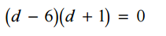
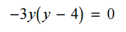
- 2)

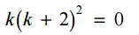
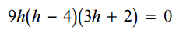
- 4)

I can factor polynomials using the GCF (7.4)

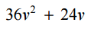
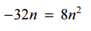
- 6)

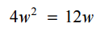
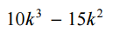
- 8)
Station 2
I can use the zero-product property to solve real-life problems. (7.4)

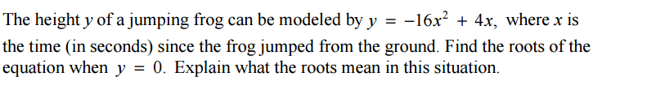

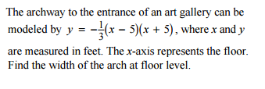

Station 3
I factor $ax^{2}+bx+c$. (7.5/7.6)

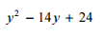
- 12)

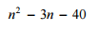
- 14)

- 16)

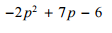
17) 18)

Station 4
I can use factoring to solve real-life problems. (7.5/7.6 and 7.7 and 7.8)
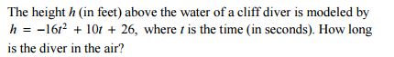
19)

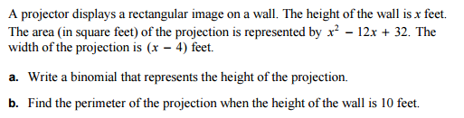
20)

Station 5
I can factor the difference of two squares. (7.7)

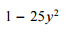
21) 22)

23) 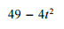 24) 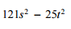
I can factor perfect square trinomials. (7.7)

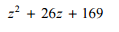
25) 26)

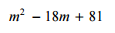
27) 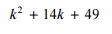 28)
Station 6
I can factor polynomials by grouping (7.8)

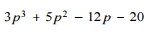
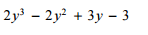
29) 30)

I can factor polynomials completely (7.7)

31) 32)

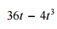
33) 34)

