Learning Target:
- How can you describe the graph of f(x) = a(x – h)²?
Success Criteria:
- I can graph quadratic functions of the form f(x) = a(x – h)²
- I can graph quadratic functions of the form f(x) = a(x – h)² + k
- I can identify even and odd functions
- I can model real-life problems using f(x) = a(x – h)² + k

Exploration:
Work with a partner. Using different colors for each graph, graph the following equations on a single coordinate plane. You can use your graphing calculator to pick points.
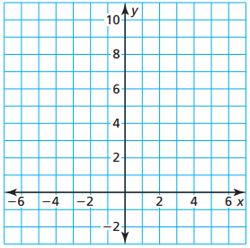
y = x²
y = (x – 3)²
y = (x + 3)²

What is similar about the graphs?
______________________________________________________________________________

What is different about the graphs?
______________________________________________________________________________

What do you think caused these differences?
______________________________________________________________________________

I can graph quadratic functions of the form f(x) = a(x – h)²
Graphing f(x) = a(x – h)²
- When _________, the graph of ______________________ is a horizontal translation h units ________ of ______________.

- When _________, the graph of ______________________ is a horizontal translation h units ________ of ______________.

Note: The vertex of the graph of f(x) = a(x – h)² is ________, and the axis of symmetry is ______.

Example 1: Graph the following. Compare each graph to the graph of f(x) = x².
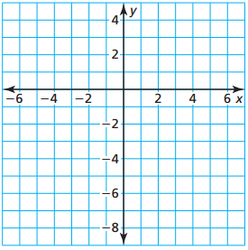
- y = ½(x + 2)² You try: b) y = -(x – 2)²

Comparison: ________________ Comparison: ________________
_________________________ _________________________

I can graph quadratic functions of the form f(x) = a(x – h)² + k
Graphing f(x) = a(x – h)² + k
Vertex form: ______________________ where ________. The graph is a translation ____ units ________________ and ____ units ________________ of the graph __________.
Note: The vertex of the graph is ________ and the axis of symmetry is ________.

Example 2: Graph each of the following. Compare each graph to the graph of f(x) = x².
- g(x) = -3(x + 2)² + 2 b) h(x) = ½(x + 4)² – 2

Comparison: ________________ Comparison: ________________
_________________________ _________________________

You try: f(x) = 3(x – 1)² + 6
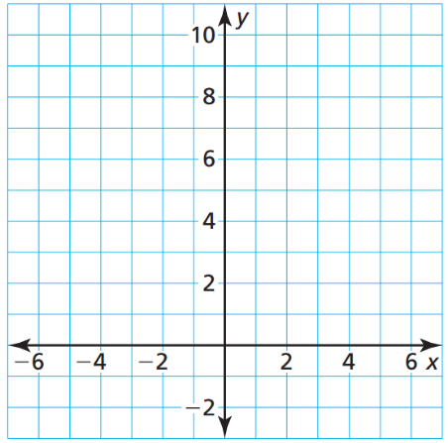

Comparison: ________________
_________________________
I can identify even and odd functions
Even and Odd Functions
- A function __________ is _________ when __________________ for each x in the domain of f. The graph is symmetric about the ____________.

- A function __________ is _________ when __________________ for each x in the domain of f. The graph is symmetric about the ____________ (it looks the same after reflections in the x-axis and then in the y-axis.

Example 3: Determine whether each function is even, odd, or neither.
- f(x) = 3x b) g(x) = 2^{x} c) h(x) = 3x² – 2x + 4

You try:
- f(x) = 5x b) g(x) = 2x² – 6 c) h(x) = 2x² + 3

Closure: What I learned today was …

