Learning Target:
- How can you use “completing the square” to solve a quadratic equation?
Success Criteria:
- I can complete the square for expressions of the form x² + bx
- I can solve quadratic equations by completing the square
- I can find and use maximum and minimum values
- I can solve real-life problems by completing the square
I can complete the square for expressions of the form x² + bx
Completing the Square: for an expression of the form ______________, you can add a constant ____ to the expression so that __________________ is a perfect square trinomial.
Step 1: Find ½ of b, the coefficient of x.
Step 2: Square the result of Step 1.
Step 3: Add the result from Step 2 to x² + bx
Step 4: Factor the trinomial

Example 1: Complete the square for the expression. Then factor the trinomial.
- x² + 18x b) x² – 3x

You try: x² – 4x You try: x² + 14x

I can solve quadratic equations by completing the square
Solving Quadratic Equations by Completing the Square
The method of Completing the Square can be used to solve any quadratic equation. The equation must be written in the form ____________________________. To keep the equation balanced, the result of Step 2 from above must be added to BOTH sides of the equation.
Example 2: Solve by Completing the Square.
- x² – 18x = -17 b) m² + 12m = -8

You try: x² – 2x = 3

- x² – 12x + 9 = 0 d) 2x² + 12x – 10 = 0

You try: x² + 14x – 10 = 0 You try: 3x² + 6x – 9 = 0

I can find and use maximum and minimum values
Recall: The ____________ of a quadratic function can be used to find the ________________ or _________________ value of the function. We can use Completing the Square to write a quadratic in vertex form, ____________________________, to find the max/min value.
Example 3: Find the maximum or minimum value of each quadratic function.
- y = x² + 8x + 5 b) y = -x² + 4x + 2

Max OR Min Max OR Min
You try: y = x² -10x + 8 You try: y = -x² + 8x – 2

Max OR Min Max OR Min

Example 4: Which of the functions could be represented by the graph? Explain.
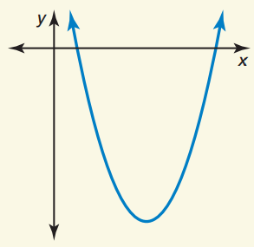
f(x) = (x – 4)² + 9

g(x) = -(x – 3)² + 5

m(x) = -$\frac{1}{4}$(x + 2)(x + 6)

p(x) = (x – 1)(x – 7)

I can solve real-life problems by completing the square
Example 5: The function y = -16x² + 160x represents the height y (in feet) of a model rocket x seconds after it is launched.
- Find the maximum height of the rocket.

- Find and interpret the axis of symmetry.

Example 6: You decide to put a rug on a floor. You want the rug to cover 100 square feet and to have a uniform border of floor visible, as shown. Find the width of the border to the nearest inch.
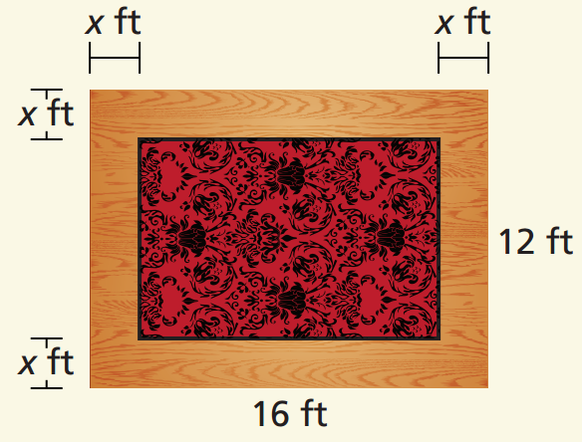

Closure: What I learned today was…

