Learning Target:
- How can you derive a formula that can be used to write the solutions of any quadratic equation in standard form?
Success Criteria:
- I can solve quadratic equations using the Quadratic Formula
- I can interpret the discriminant
- I can choose efficient methods for solving quadratic equations

I can solve quadratic equations using the Quadratic Formula
Quadratic Formula:

This formula is used to find the real solutions of the quadratic equation ax² + bx + c = 0, where _________, and ______________________.
Example 1: Solve the equation using the Quadratic Formula. Round your solutions to the nearest tenth, if necessary.
- x² + 6x - 13 = 0 b) -3x² + 5x – 1 = -7

You try: x² + 2x – 12 = 0 You try: 12x² – 4x – 5 = 0

Example 2: The number y of Northern Rocky Mountain wolf breeding pairs x years since 1990 can be modeled by the function y = 0.20x² + 1.8x – 3. When were there about 77 breeding pairs of wolves?

I can interpret the discriminant
Discriminant: In the Quadratic Formula, the expression _______________ is called the discriminant. Since the discriminant is under the square root, its value allows us to see the ______________ of solutions that the quadratic equation has.

b² – 4ac > 0 b² – 4ac = 0 b² – 4ac < 0
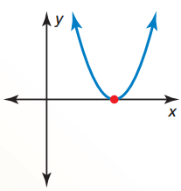
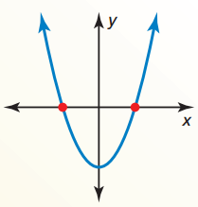
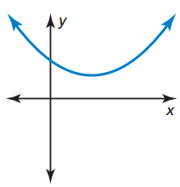

____________________ ____________________ ____________________

Example 3: Determine the number of real solutions of each quadratic.
- –x² + 6x + 3 = 0 b) x² + 3x + 8 = 0

You try: 2x² – 3x – 1 = 0 You try: 6x² + 2x + 1 = 0

Example 4: Find the number of x-intercepts of each graph using the discriminant. Check your results by graphing.
- y = 2x² – 4x – 3 b) y = -x² – 8x – 18

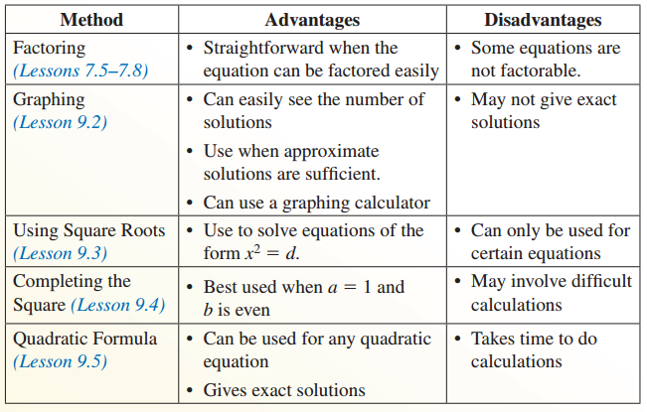
I can choose efficient methods for solving quadratic equations
Overview of Methods

Example 5: Solve the equation using any method. Explain your choice of method.
- x² – 4x – 7 = 0 b) (x – 2)² = 64

- 10x² + 7x – 12 = 0 d) 3x² + x – 5 = 0

Closure: What I learned today was…

