Success Criteria Self Evaluation
Rate your level of understanding with the scale below before beginning the review activity. After completing the review activity, rate your level of understanding again. This will help identify any s that need to be re-looked at before the assessment, which is next class.
1 = Need Help! 2 = Kind Of! 3 = Almost! 4 = Got It!
Section | Success Criteria | Rating Before Activity | Rating After Activity
9.4 | I can complete the square for expressions of the form x² + bx | 1 2 3 4 | 1 2 3 4
 | I can solve quadratic equations by completing the square | 1 2 3 4 | 1 2 3 4
9.5 | I can solve quadratic equations using the Quadratic Formula | 1 2 3 4 | 1 2 3 4
 | I can interpret the discriminant | 1 2 3 4 | 1 2 3 4
 | I can choose efficient methods for solving quadratic equations | 1 2 3 4 | 1 2 3 4
9.6 | I can solve systems of nonlinear equations by graphing | 1 2 3 4 | 1 2 3 4
 | I can solve systems of nonlinear equations algebraically | 1 2 3 4 | 1 2 3 4

Station 1:
- 2.

____________________ ____________________
- 4.

____________________ ____________________
- 6.

____________________ ____________________
Station 2:
- 2.

____________________ ____________________
- 4.

____________________ ____________________
Station 3:
- 2.

____________________ ____________________
- 4.

____________________ ____________________
Station 4:
- 2.

____________________ ____________________
- 4.

____________________ ____________________
- 6.

____________________ ____________________
Station 5:
- 2.

____________________ ____________________
- 4.

____________________ ____________________
Station 6:
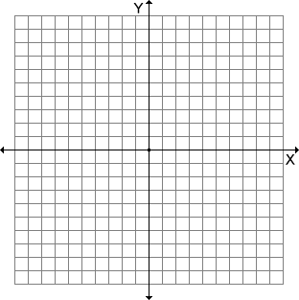
- 2.

Station 7:
- 2.

____________________ ____________________
- 4.

____________________ ____________________

