An Exploratory Study Between Advanced Courses and Extracurricular Activities Taken by High School Students

Name:
Course: IB Mathematics Standard Level
Date of Submission: 5 February 2016
Teacher: Apostolovski

Introduction
Adolescents typically face a wide range of normative chronic stressors, including academic and social demands. For high school aged youth, academic, athletic, social, and personal challenges are considered domains of “good stress” (Selye, 1974). However, there is growing awareness that many subgroups of youth experience levels of chronic stress that impact their abilities to succeed academically and maintain free time for themselves.
Furthermore, a recent study surveyed and interviewed students at various high schools and found that about half of them are chronically stressed. The results show that between the homework required for Advanced Placement classes, sports practices, extracurricular activities like music and student government, and SAT prep, the fortunate kids who have access to these opportunities don’t have much downtime. These experiences can cause students to feel the psychological and physical effects of stress for much of their adult lives, says Marya Gwadz, a senior research scientist at the New York University College of Nursing. With that, this exploratory study was conducted in order to analyze the relationship between advanced courses and extracurricular activities taken by students at Northville High School.

Method
Design
In order to study the relationship between the advanced classes and extracurricular classes taken by high school students, quantitative and qualitative survey research was used. Furthermore, a personal interview survey, also called a face-to-face survey, was utilized to reach the target population of high school students. The personal interview survey was used to probe the answers of the respondents and observe the behavior of the respondents. Furthermore, each participant was read a standard set of instructions (see Appendix I). Following the standard instructions, participants were asked two questions that relied on qualitative data. (see Appendix II). Also, a large sample size was used because it is representative of the population, while limiting the influence of outliers or extreme observations.

Participants
Opportunity and convenience sampling was used in order to find a sample of participants. The target population was a group of 100 students academically enrolled at Northville High School. This sampling technique was used because it was convenient for the course instructors and researcher. Also, a large sample size was used because it broadens the range of possible data and forms a reliable representation of the population. Furthermore, participants were asked to participate, and those who accepted were asked to take part in a short interview. All participants were students in grades ten, eleven, and twelve, at Northville High School, and were between 15 and 18 years of age.

Materials
The materials used in this study include a standard set of instructions
(see Appendix I), a questionnaire (see Appendix II), and multiple sheets for recording data (see Appendix III).
Procedure
All participants were randomly asked to participate in a quick interview. Also, all participants were individually interviewed during times convenient for course instructors and participants. Once a participant was ready to begin, they were read a brief set of standardized instructions (see Appendix I). Following the standardized instructions, participants were asked the following two questions:
- How many advanced courses are you currently enrolled in at Northville High School?
- How many extracurricular activities are you currently involved in at Northville High School?
Each question was followed up by a brief set of requirements. For example, an advanced class consists of Advanced Placement, International Baccalaureate, or Honors courses. Also, extracurricular activities require more than 30 minutes of monthly participation and could consist of sports, student government, or small clubs. Lastly, participants were thanked for their time involved in the interview.

Data Collection
Variable 1: Amount of Advanced Courses Taken
Table 1

Advanced Courses Per Semester (X) | Students With Advanced Courses (f) | f(X)
2 | 13 | 26
3 | 15 | 45
4 | 18 | 72
5 | 21 | 105
6 | 24 | 144
7 | 9 | 63
Sum | 100 | 455

Table 1: The frequency distribution table represents the amount of advanced courses taken by students. Furthermore, the frequency distribution table also represents the amount of students enrolled in various amounts of advanced courses at Northville High School. Therefore, the frequency of students enrolled in
2,3,4,5,6, and 7 advanced courses are tabulated.

Calculations
Mean of Variable 1
x̄ $=\frac{ΣX}{n}$
x̄ $=\frac{2(13)+3(15)+4(18)+5(21)+6(24)+7(9)}{100}$ $= \frac{455}{100}$
x̄ $=4.55$

Median Variable 1
Median = {(n + 1) ÷ 2}^{th} value 2,2,2,2,2,2,2,2,2,2,2,2,2,3,3,3,3,3,3,3,3,3,3,3,3,3,3,3,4,4,4,4,4,4,4,4,4,4,4,4,4,4,
4,4,4,4,5,5,5,5,5,5,5,5,5,5,5,5,5,5,5,5,5,5,5,5,5,6,6,6,6,6,6,6,6,6,6,6,6,6,6,6,6,6,6,6,6,6,6,6,6,7,7,7,7,7,7,7,7,7
= (100 + 1) ÷ 2
= (101) ÷ 2
= 50.5
$∴$Average = (value below median + value above median) ÷ 2
= (5 + 5) ÷ 2
= 10÷ 2
= 5
Mode of Variable 1
Advanced Courses Per Semester (X) | Students With Advanced Courses (f) | f(X)
6 | 24 | 144

$∴$ The mode is 6 advanced courses per semester

Discussion
A measure of central tendency is a single value that attempts to describe a set of data by identifying the central position within that set of data. The mean, median, and mode are all measures of central tendency. Furthermore, the mean is an accurate measure of center if the distribution is symmetrical or approximately symmetrical. In this case however, the distribution is not symmetrical or approximately symmetrical (Graph 1). Therefore, the mean would not be an accurate measure of central tendency because as the data becomes skewed the mean loses its ability to provide the best central location for the data. That is due to the fact that the skewed data is dragging it away from the typical value. Therefore, the mean would be an inaccurate measure of central tendency for this data. However, the median best retains this position and is not as strongly influenced by the skewed values.
The median however, is the only measure of center that will locate the true center regardless of the data set’s feature. Therefore, the median of 5 Advanced Courses would be most accurate when describing the central tendency of the data. Since the data shows a negatively skewed distribution (Graph 1), it is apparent that the data includes outliers. However, the median is unaffected by the presence of extreme values, and is known as a resistant measure of the center. Therefore, the median would be the most accurate measure of center.

Graph 1

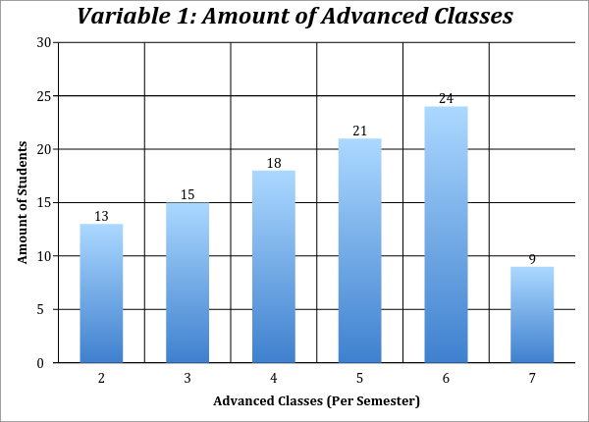
Graph 1: Graph 1 shows a negatively skewed distribution of the amount of advanced courses taken by students. Furthermore, the column graph of discrete data represents the amount of students enrolled in various amounts of advanced courses at Northville High School.

Range of Variable 1
Range = Maximum Value – Minimum Value
= 7 – 2
= 5

Interquartile Range of Variable 1
Boxplot 1

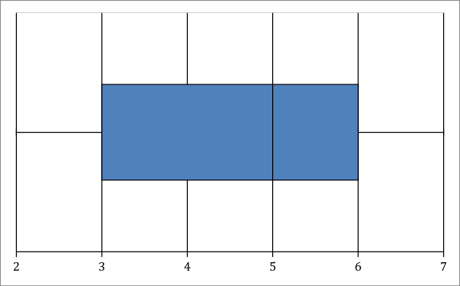
Boxplot 1: The box and whisker plot is a visual display of some of the descriptive statistics of the data set. It shows the minimum value (2), the lower quartile (3), the median (5), the upper quartile (6), and the maximum value (7). Moreover, the boxplot shows a negatively skewed distribution.

Interquartile range = upper quartile – lower quartile
$Q_{1}$ = 3
$Q_{3}$ = 6
$∴$ IQR = $Q_{3}$ - $Q_{1}$
= 6 – 3
= 3

Standard Deviation of Variable 1
x | f | fx | x - x̄ | $${(x-x)}^{2}$$ | f${(x-x)}^{2}$
2 | 13 | 26 | -2.55 | 6.5025 | 84.5325
3 | 15 | 45 | -1.55 | 2.4025 | 36.0375
4 | 18 | 72 | -.55 | .3025 | 5.445
5 | 21 | 105 | .45 | .2025 | 4.2525
6 | 24 | 144 | 1.45 | 2.1025 | 50.46
7 | 9 | 63 | 2.45 | 6.0025 | 54.0225
Total | 100 | 455 |  |  | 234.75

x̄ = $\frac{Σfx}{n}$ = $\frac{455}{100}$ = 4.55
$S_{n}$ =$\sqrt{\frac{Σf{(X-X)}^{2}}{n}}$
= $\sqrt{\frac{234.75}{100}}$
$≈$ 1.53
Variance of Variable 1
$S_{n^{2}}$ =$\frac{Σf{(X-X)}^{2}}{n}$
= $\frac{234.75}{100}$
$≈$ 2.35

Discussion
A measure of spread is used to describe the variability in a sample or population. It is usually used in conjunction with a measure of central tendency, such as the mean, to provide an overall description of a set of data. A measure of spread gives a representation of how well the mean, for example, represents the data. If the spread of values in the data set is large, the mean is not as representative of the data as if the spread of data is small. This is because a large spread indicates that there are probably large differences between data points.
Standard deviation is the best measure of spread of an approximately normal distribution. This is not the case when the distribution is negatively skewed. In this situation, interquartile range is the preferred measures of spread. Interquartile range is the difference between the 25th and 75th centiles. Quartiles are a useful measure of spread because they are much less affected by outliers or a skewed data set than the equivalent measures of mean and standard deviation. For this reason, quartiles are reported along with the median as the best choice of measure of spread and central tendency, respectively, when dealing with skewed and/or data with outliers.
However, the problem with using the range and the IQR as measures of spread or dispersion of scores is that both of them only use two values in their calculation. Therefore, data sets can have their spread characteristics hidden when using IQR

Graph 2
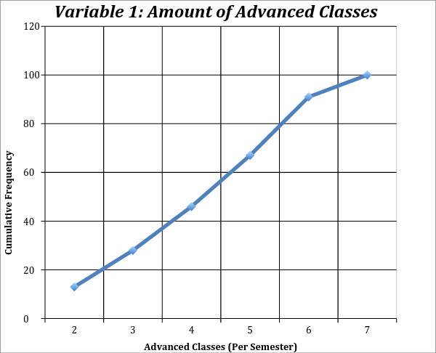
Graph 2: The cumulative frequency graph of the amount of advanced classes was graphed in order to know the number or proportion of score that lie above or below a particular value. Furthermore, students with six advanced classes fall under the 90 percentile, as inferred from the cumulative frequency graph.

Variable 1 & 2: Amount of Advanced Courses & Extracurricular Activities
Graph 3
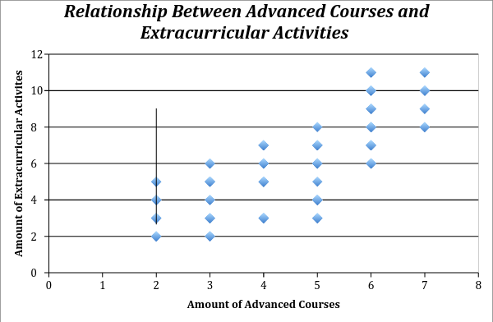
Discussion
To begin, the relationship between advanced courses and extracurricular activities shows a moderate positive correlation. Moreover, the Pearson’s Correlation Coefficient provides a more precise measure of the strength of the linear correlation between the two variables. In this case, Pearson’s Correlation Coefficient is a value of r = .78. As previously mentioned, this shows a moderate positive correlation between advanced courses and extracurricular activities. Furthermore, the problem with drawing a line of best fit by eye is that the line drawn will vary from graph to graph. The line of best fit was found to be y = 1.3x(.095). Therefore, the least squares regression line was used because it provides a line that makes the sum of all squares as small as possible.
We use the least squares regression line to estimate values of one variable given a value for the other. If we use values of x outside the poles, it is known as extrapolation. The accuracy of an extrapolation depends not only on how linear the original data was, but also on the assumption that the linear trend will continue past the poles. Therefore, if a value were to be extrapolated from the graph above, we would first have to understand the general trend. The moderate trend shows that as the amount of advanced courses increase, so does the involvement in extracurricular activities. If values were to be interpolated from the line of best fit, it would show that students with 2 advanced courses take part in, on average, 3 extracurricular activities, and student with 3 advanced courses take part in, on average, 4 extracurricular activities, and so on. It could be assumed that students enrolled in 8 advanced classes take part in 10 extracurricular activities. However, it cannot be said that students enrolled in 9 advanced classes take part in 11 extracurricular activities, because 9 advanced classes are not offered per semester at Northville High School.

Appendices

Appendix I – Standardized Instructions
- I am conducting an exploratory study between advanced courses and extracurricular activities taken by high school students.
- I will ask you three questions and record your responses.
- Please try to answer each of these questions to the best of your ability.
- Do you have any questions?

Appendix II – Interview Questions
- How many advanced courses are you currently enrolled in at Northville High School?
  - That would consist of AP, IB, and Honors courses.
- How many extracurricular activities are you currently involved in at Northville High School?
  - That would consist of any group or team that requires more than 60 minutes of monthly participation.

Appendix III – Raw Data
2 | 2
2 | 2
2 | 2
2 | 3
2 | 3
2 | 3
2 | 3
2 | 4
2 | 4
2 | 4
2 | 4
2 | 5
2 | 5
3 | 2
3 | 2
3 | 2
3 | 3
3 | 3
3 | 3
3 | 3
3 | 4
3 | 4
3 | 5
3 | 5
3 | 5
3 | 5
3 | 6
3 | 6
4 | 3
4 | 3
4 | 3
4 | 3
4 | 3
4 | 5
4 | 5
4 | 5
4 | 5
4 | 5
4 | 6
4 | 6
4 | 6
4 | 6
4 | 7
4 | 7
4 | 7
4 | 7
5 | 3
5 | 3
5 | 3
5 | 4
5 | 4
5 | 4
5 | 4
5 | 4
5 | 4
5 | 4
5 | 6
5 | 6
5 | 7
5 | 7
5 | 7
5 | 7
5 | 6
5 | 6
5 | 6
5 | 5
5 | 8
6 | 6
6 | 6
6 | 6
6 | 6
6 | 7
6 | 7
6 | 7
6 | 7
6 | 8
6 | 8
6 | 8
6 | 9
6 | 9
6 | 9
6 | 10
6 | 10
6 | 11
6 | 11
6 | 10
6 | 10
6 | 11
6 | 9
6 | 9
6 | 8
7 | 8
7 | 8
7 | 9
7 | 9
7 | 10
7 | 10
7 | 10
7 | 11
7 | 11

